**Second Year Lab Equipment Redesign**

Supervisor: Peter O’Donoghue ([podonoghue@swin.edu.au](mailto:podonoghue@swin.edu.au))

Team Name: Frolicking Flamingos

Date: 16 August 2019

Team Members

Jordan Boekel ID: 101625077

Ben Gregg ID: 101612927

Patrick Curtain ID: 101109830

***Executive Summary***

The use of PCB lab equipment throughout EEE20001 has allowed for the practical implementation of various microprocessor applications for students. The current board provides various functions such as clock and traffic light modules to demonstrate several programming algorithms and techniques, as well as differing designs for coding implementation.

The board however, after 10 years of use, has become outdated and impractical in many respects. Currently the board is shared amongst several students, limiting use of the board amongst groups. Students are unable to work independently with the board due to lack of access. Its current through hole design also increases manufacturing costs and makes for a bulky design that with its accompanying power brick is inconvenient to store in a box.

In response to these issues this project aims to redesign the current PCBs used as lab equipment. The redesign’s objective being to decrease its total footprint for a slimmer design, decrease the total manufacturing cost and implement additional features for modern use of the board such as an integrated power supply using USB. A surface mount design (SMD) will be used in the design approach due to the cost effectiveness of components and their relatively small profile.

This project will be conducted by a group of three that will perform both the research and design of the board (specifics are listed in deliverables). Roles will be delegated according to the roles of each member (detailed below) and a business case made for the new design’s wider implementation.

Contents

*Statement of Problem* 2

Introduction 2

Background: 3

Strategy 4

Tasks: 4

Goals: 4

1. Required Work 5

2. Qualification 5

Project Management: 6

Roles 6

Jordan Boekel: 6

Ben Gregg: 7

Patrick Curtain: 7

Finance 7

Deliverable Outcomes: 8

# Statement of Problem

To redesign the EEE20001 PCB lab equipment to be smaller, cheaper, and with additional features for use during labs.

# Introduction

The current lab equipment for EEE20001 is an ageing and expensive to manufacture design, requiring extensive work by the university to produce the required equipment. The goal in this case is to design and organize the manufacture of a new PCB design, with a view to minimising cost and size while maximising reliability. This will allow for more practical use of the boards by students and their continued longevity for the university. Added features will enhance ease of use and allow for a cleaner more robust learning experience.

# Background:

Feedback from the client suggests that a design using more modern surface mount components will reduce the size and cost of the design, with an emphasis on reduction of labour costs and final assembly requirements.

The modular nature of the previous generation assembly, though attractive, proved to be unnecessary and expensive. This cost limited the students access to the equipment, with groups of two or three formed to share a single board. This in turn limited some student's exposure to the equipment, if their group mates were tasked with care of the equipment. The modular design unnecessarily increases the footprint and volume of the equipment, making storage more difficult for students, with poor handling damaging components.

The barrel style jack and large switch-mode supply used to power the equipment has proved to be tedious to carry and store, and the need to have access to a power point has limited the portability of the device. In some cases, access to power points within the laboratory has dictated seating arrangements, most of which are not convenient.

A large scale production run of the PCB should aim to use lead free manufacturing techniques to minimise the environmental impacts of the disposal of the equipment. The PCB components and design as a whole need to be recyclable or disposed of in a manner that is not ecologically harmful.

Australian laws on international imports will also need to be considered, given that the final product will likely be manufactured overseas. The current economic climate will also play a role in the financial viability of these circuit board. Of consideration is the presently weak buying power of the Australian Dollar currently will limit the cost even further. High value import tax and duties can be a relevant concern due to significant increases to the final cost beyond just the purchase and manufacture and something that must be factored into the cost.

# Strategy

To successfully design and implement a new PCB surface mount design various goals and deadlines need to be met. To this end the team has laid out goals and tasks to be completed over the course of the project. These are specified and detailed below. These tasks have then been further divided and delegated as shown in both the group roles and project management sections of this proposal.

## Tasks:

* Identify key features and interfaces of the existing design

This will involve analyzing the existing design, so that a new board can be produced with matching (or similar) interfacing to allow for compatibility. Additionally, the primary features of the existing design are identified so that these can be prioritized in the production of a new board.

* Design new equipment (with updated features and improvements) to the existing specification

At this stage, work will begin on fully implementing a new design. This includes PCB layout, component selection and microcontroller programming. Allowances will be made for the inclusion of new features, such as a display for showing the clock, rather than the existing LED table.

* Organise the full manufacture of PCBs (including part soldering)

With a completed design, work will start on organizing full manufacture of the PCBs. This involves finding a company to produce the PCBs, and ideally capable of performing the requisite processes to assemble of the board. At the very least SMD manufacture must be undertaken, as these parts are difficult to perform by hand, and impractical when many boards need to be produced. A manufacturer must be found that can source the parts necessary for completion of the final product.

## Goals:

* Minimise the cost of the new design.

The main aim in the new design is to minimize the manufacturing cost, so that every student can be provided with a board. More boards will encourage more student interaction with the hardware and enhance the experience with the board.

* Add new features or update existing aspects. These could include aspects such as an LCD/OLED screen to display the clock, better interfacing with pcb etc)

Since a new design is being produced, the boards will also be updated and improved, since there is minimal cost to changing or updating if an entirely new set of equipment is being produced.

* Reduce the footprint of the board

As the old design was found to be unnecessarily large, the new design will use a smaller footprint, for better portability, storage and manufacturing cost.

### Required Work

The current modules used in the lab are ageing and expensive to produce. As a result, students must work in groups of two for each set of lab equipment. The aim in this case is to minimise the cost of the equipment to allow each student access to a board of their own.

Also, the current equipment uses a barrel jack for power, which is inconvenient compared to modern standards such as a USB supply. Especially considering the power supply currently exists in the form of an external power brick. Moving to a modern standard of usb and integrating the power supply to the board will allow for a more convenient and compact product.

To achieve this the board will first need to be compacted onto a smaller footprint PCB with components redesigned, replaced and repositioned to fit the new format. A new power supply will also need to be researched and designed to supply the board and the individual modules reworked to be more compact. These modules will also need to be redesigned to integrate with any additional features deemed plausible and practicable to the design. Further circuit protection, pin debouncing and other operational features will also need to be designed into the board to ensure safe and reliable operation.

### Qualification

As third year electrical engineering students, having gained considerable knowledge on electrical circuits and programming, we are prepared to undertake both the technical and design requirements of this project. Previously working with the current EEE20001 boards the team has considerable experience in its application and the function of each of the attached modules. Previous use also further gives insights into the strengths and shortcomings of practically using the current laboratory equipment in groups. This gives educated insight into potential solutions to these problems. Individual experience using Arduino, MBED OS, and other IDEs has provided experience in microprocessor programming which will be a significant feature of designing the new hardware.

Within the allotted 12 weeks the project is planned to have completed 2 modules as well as a basic redesign of the board and interface. Following the plan given in project management and the Gantt chart it is believed these modules should be completed and prototyped by the end of the designated period.

# Project Management:

Management of the project is paramount to the delivery of goals and outcomes for the proposal. In order to conduct proper research, design and production, time must be effectively delegated between tasks to achieve the highest level of design.

This project is to span the course of 12 weeks between 14th August – 28th October. The below Gant chart details the general project timeline and forecasted completion dates.

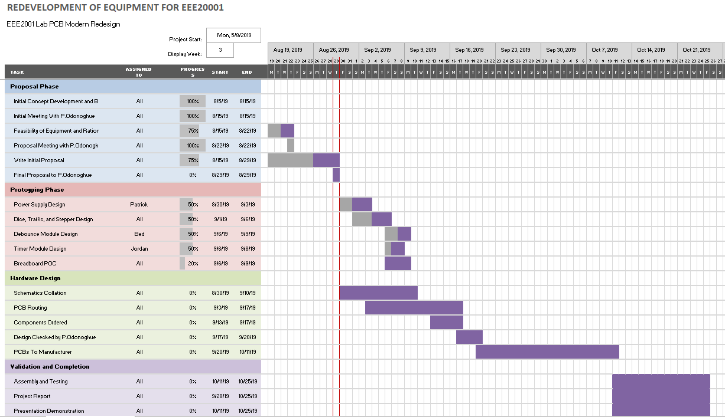

The project will be completed in multiple stages:

* Planning: Develop an approach to create a solution for the given task.
* Concept: Create a general overview of the aims and requirements for the project, and ideas for solving these problems.
* Development: Designing a solution for the given task – PCB design, choosing parts and programming. Investigate possible manufacturers for a final design, and ensure that the development specification is suitable for production.
* Prototype and testing: Verifying the functionality of the initial design and ensuring it meets the requirements.
* Refinement and manufacture: Using data from the testing stage, make changes and send the design off for manufacture.

# Roles

## Jordan Boekel:

* Primarily microprocessor related tasks
* Microprocessor program – clock generator and traffic module.
* Pin layout specification for placement and PCB routing.
* Research interfacing with the processor on PCB (ie USB, bootloader etc).
* LCD interfacing with the processor.
* Deliverables

## Ben Gregg:

* Debounce circuitry:
* TL circuit design:
* Interfacing with the processor on the PCB:
* Any extra work for additional modules:
* Component Research

## Patrick Curtain:

* PCB layout/design: Track design, component positions
* Power supply design:
* PCB Manufacture:
* User Research

If any complications are encountered during the project, task assignments may be adjusted to allow us to fairly share work.

# Finance

The budget section is obviously very important to every decision-maker. They need an estimate of the cost before they can give it a go-ahead. For this reason, the proposal template doc must contain accurate facts and figures as well as a well-researched estimate of maintenance cost. Give all supporting details.

A key goal of this project is to produce a board that will be affordable for a single board per student. As such we are aiming for a product that will cost the university somewhere within the range of $60-80, with the majorities of those costs due to labour. The cost effectiveness of the design of the previous board was outweighed by the labour costs associated with assembling them by hand using university resources. We aim to design a product that can be produced primarily using SMD and automated assembly techniques, so that it can be manufactured cheaply.

The principle costs of manufacturing will be broken down into two categories:

* Components, such as resistors, capacitors, basic logic chips and microprocessors.
* Assembly – production of the PCB, assembly and shipping

A more in-depth costing of the will be available as the project progresses and the final design settles, with an aim to constrain ourselves to this margin.

# Deliverable Outcomes:

The aim is to provide a design with two - three fully implemented modules, ready to be produced in its entirety by a third-party manufacturer. The resulting deliverables are:

* General redesign of the board
* Reworked power supply
* Fully completed two modules of the board (one of these to be the Traffic Lights or Clock modules) with the aspiration to complete three.
* The prototype boards
* Circuit diagrams, design drawings (Altium), documentation of components
* Full costings for the manufacture of the board.
* Any required code for the processors in the modules.

The advantages of this proposed design are reduced costs, size, and an updated feature set. Reduced size will increase portability and reduce costs, while reduced costs will hopefully allow all students to be provided with their own lab kits. New features such as USB connectivity will make the board simpler to work with, and a display for the clock generator will be easier to read.